249 458 888 1109 1563 1796

an illusion; lunchtime, doubly so. -- Ford Prefect

610 987 2584 10946 46368 196418

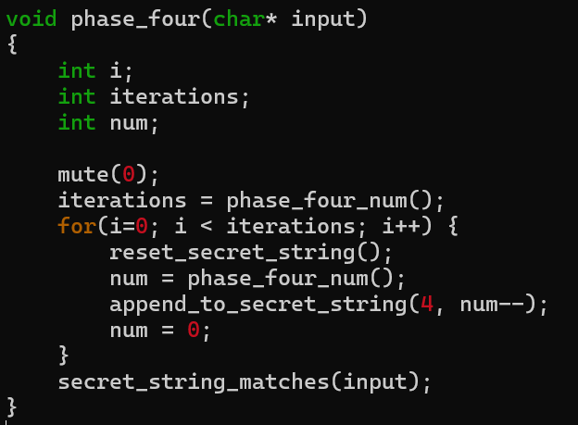

7582

Phase 6:

117 54 55 147 114

fortuneList ->next-> next->next->next->len \*3

(int)((fortuneList->next->data)[9])

vwxyzabcdefgh indestructible

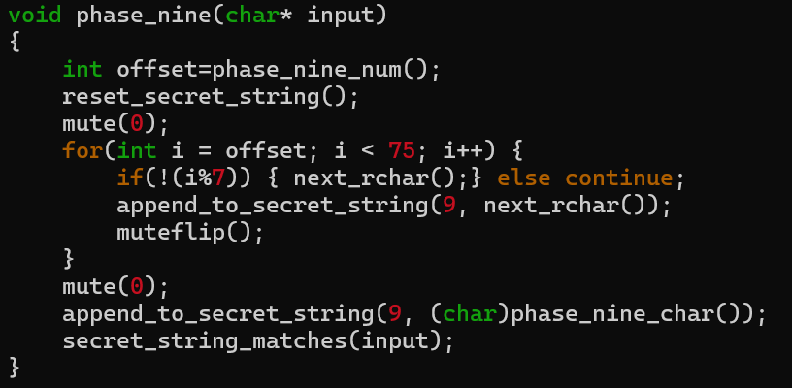

S { , a u \